Emmaus Gathering
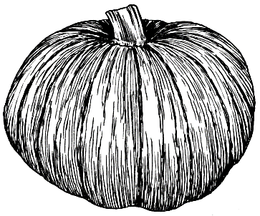Come Share
This Photo by Unknown Author is licensed under
Our Tables….
Christ Table & Potluck
Saturday, November 9th
St. Peter’s United Church of Christ
125 Church St. Elmhurst, IL
Sponsored by: Elmhurst Reunion Group

Share at Worship 4:30 to 5:30
Clergy –
4th Day Talks
Christ’s Table Served
Community and Potluck to follow
Please bring a dish to share

